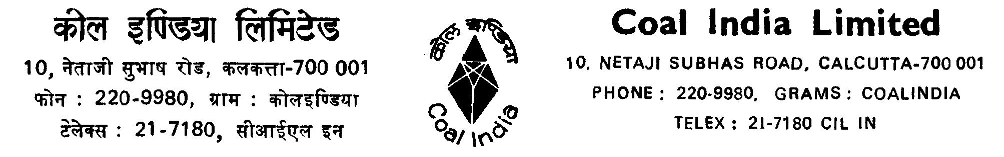

No. CIL/ C5C/CPRMSE/ 180 Date: 03.03.2010

Office Order

Further to this Office Order No. CIL/C5C/CPRMSE/145 dated 31.10.09 regarding
submission of ‘Life Certificate’ by the retired executives and/or spouse every year in the month of
December, the ‘Life Certificate’ may also be issued by an officer of the company from where the
medical facility is obtained, besides the persons as indicated in the above mentioned Office Order
dated 31.10.09. A format of the ‘Life Certificate’ is enclosed for all concerned.

This issues with the approval of the Competent Authority.

Encl. As stated
(A.K. Verma)
Chief General Manager (Welfare)
Distribution:
Directors - Technical/P & IR/Marketing/Finance – CIL, Kolkata
CMDs – ECL/BCCL/CCL/WCL/SECL/NCL/MCL/CMPDIL
Directors – Personnel/Finance - ECL/BCCL/CCL/WCL/SECL/NCL/MCL
Director (Tech.)/(Operation) - CMPDIL
CVO, CIL, Kolkata
E.D. – IICM, Ranchi
CGM/TS to Chairman, CIL, Kolkata,
C.G.M. (Finance) , CIL, Kolkata
C.G.M., NEC
CGM, CIL, New Delhi
E.D. (MS), CIL – CCL, Ranchi
Chief of Medical Services - ECL/BCCL/CCL/WCL/SECL/NCL/MCL
I/C GM, CCL
CPM (EE), NCL
Dy CPM (EE), SECL, ECL,
Dy. CME (EE), WCL
HOD (EE) –BCCL
T.S. to Director (P & IR) CIL, Kolkata
PM (Welfare), MCL,
Estate Manager (W), CMPDIL ,
Medical Supdt., CIL, Kolkata
All RSMs, RSOs, CIL

LIFE CERTIFICATE

To whom it may concern

This is to certify that Shri __________________________________ son of

____________________________ / Smt _________________________________ wife of

____________________________________ residing at ______________________________

____________________________________________________ is known to me.

Shri/Smt ________________________________ is alive at the time of issuing this certificate. This

certificate is issued for release of payment for outdoor/domiciliary treatment. The signature of

Shri/Smt _______________________________ is attested hereunder.

Shri/Smt__________________________

Signature Attested

__________________________________________________
Signature of Registered Medical Practitioner with Reg. No. OR
Gazetted Officer of Central/State Govt. OR
The Branch Manager of the Bank where the retired
Executive/spouse is holding S.B. A/C OR
Any Officer of the company from where
the medical facility is obtained
With Seal /Stamp
Date:

